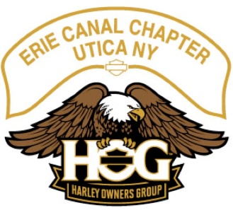
Monthly HOG Meeting
Date: ___10/06/2022____ taken by ______Amber Poole__

Officers: Present Absent
Director: Gary Cioch __X___ ______
Assistant Director: Mark Kosinski __X___ ______
Secretary: Amber Poole __X___ ______
Treasurer: Patty Terenzetti __X___ ______
Ladies of Harley Officer: Daris Kosinski __X___ ______
Historian: Don Ehre __X___ ______
Activities Officer: Roger Potenski __X___ ______
Photographer: Frank Wrisley __X___ ______

Call to Order: Called the meeting to order at ___6:38___ Door Prize:_Harley Mug_
Meeting Minutes:
The ____Sept 2022_____ meeting minutes were approved on a motion from _Floyd Goodhines____ second by ___Gary Cioch__.
Treasurer’s Report:
Approved on a motion from __ Floyd Goodhines _____ second by __Gary Cioch___.
Corrections:
Old Business: None
New Business:
- ABC Pictures are to be turned in at or before the November meeting to Gary Cioch.
- The dealership check-in is to be turned in to by December 31st. Log into the Hog Website go to your own account to upload photos under the Ride 365 section - Do Not use the App.
- Your end of season odometer photo should be sent to Jeff Christman at Jeff.Christman@HDUTICA.com by December 31st.
- Nominations for officers begin at the November meeting and extend until the election at the December meeting. Nominations can be made at the meetings or sent to Gary at Gary.Cioch@yahoo.com
- Don questioned if new members will receive water bottles. - It was said to be done until they are gone.
- Roger brought up if we are having a late January/February Holiday party at Michael T’s - He was told to go ahead and start researching it.
- Mention of if we should hold a blind auction again at the party. - It will be.
- Harley Davidson’s dealer warranty has been altered so work can be done by other parties. Any work that you have done should be documented.

Next Meeting Action Points: Roger maybe looking into the venue for the party.

Adjourned at: ___Not Sure____

