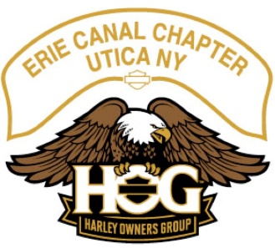
Monthly HOG Meeting
Date: ___12/01/2022____ taken by __Mark Kosinski and Amber Poole_

Officers: Present
Director: Gary Cioch __X___
Assistant Director: Mark Kosinski __X___
Secretary: Amber Poole __X___
Treasurer: Patty Terenzetti __X___
Ladies of Harley Officer: Daris Kosinski __X___
Historian: Don Ehre __X___
Activities Officer: Roger Potenski __X___
Photographer: Frank Wrisley __X___

Call to Order: Called the meeting to order at ___6:45___ Door Prize: Tea Cups_
Meeting Minutes:
The ____Oct 2022_____ meeting minutes were approved on a motion from _Daris____ second by ___Gary Cioch__.
Treasurer’s Report:
Approved on a motion from __ _____ second by __Gary Cioch___.
Corrections: None
Old Business: None
New Business:
- There is a place at the dealership to drop of Toys for Tots.
- Dealership has a promo – spend 100 bucks and you could win a 4 wheeler or something like that.
- Your end of season odometer photo should be sent to Jeff Christman at Jeff.Christman@HDUTICA.com by December 31st.
- There are roughly 15 responses to the FB Poll for interest in “the Party”.
- Roger is moving forward with setting the party, tickets are 23 bucks apiece.
- HOG has 10 rides for 25 rides which is nationwide, none are in NY.
- If you take a Rider Safety Course there is an incentive of 50 bucks.
- Rally rides:
  - Louisiana to Florida
  - California to Arizona
  - LePasa Texas to La Junetous Louisiana
  - Indianapolis to Louisiana
  - Texarkana Texas to Columbia Missouri
  - Tacoma Washington to Chico California
- Rallies:
  - Fredericksburg June 26-29
  - Gettyburg August 16-19
  - Clearwater October 4-7
- HOG ROC training closest one is in Binghamton NY on April 15th

Next Meeting Action Points: None

Adjourned at: __7:05__

