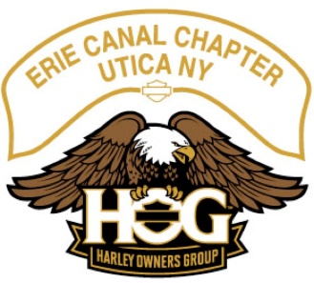
Monthly HOG Meeting
Date: ___04/06/2022____ taken by __Mark Kosinski _

Officers: Present
Director: Gary Cioch __X___
Assistant Director: Mark Kosinski __X___
Secretary: Mark Kosinski (filling in) __X___
Treasurer: Patty Terenzetti __X___
Ladies of Harley Officer: Daris Kosinski __X___
Historian: Don Ehre __X___
Activities Officer: Roger Potenski __X___
Photographer: Frank Wrisley __ ___

Call to Order: Called the meeting to order at ___6:42___ Door Prize: Amber won the door prize which was a kicking HD jacket worth 150.
Meeting Minutes:
The _March 2023_ meeting minutes were approved on a motion from _Floyd_ second by _Jim .
Treasurer’s Report:
Approved on a motion from _Mark _ second by __ Roger___.
Corrections: None
Old Business: None
New Business:
- There is ongoing correspondence with Ray Norse for a two Chapter Ride with the Syracuse NY Chapter.
- There needs to be an email or post on FB to indicate if there is interest in getting Chapter Sweat Shirts.
- Patty mentioned the promo cards for HOG miles, she has not received hers yet and Gary has not either. Jeff Christman is currently looking into the reason why the cards have not been sent out yet.
- On to the Rides:
- There was discussion pertaining the ride to Kingston Ontario and Covid restrictions, forms of ID required, and the ferry may or may not be running. A vote was taken and this ride was cancelled for this year.
- Rides have been discussed and logged.
- Possibilities for rides: Jumpin Jacks, Heritage Hill Brewery, Dan’s Chicken Shack, Speculator Inn, Tugger’s, Wanakeena, Grand Gorge for the view, Margaretville or Sundays, Indian Lake for Ribs, Oxbow Falls, State Park just south of Tupper Lake for brown bag lunch, Miller’s Meats for a Friday ride (BBQ), evening rides are possible, Full moon rides were mentioned, and Speedies which is where we went last year on Memorial Day.
- Recall rides are optional and this year all trikes are to ride at the back of the pack.
- Scheduled Rides not in order:
- June 10th Dan’s Chicken Shack, meet at Fast-track in Rome at 9:45.
- July 1st Heritage Hill Brewery meet at UHD at 10:45.
- June 3rd Vet Ride, non HOG ride, but we may discuss a ride after this event. I did not get the time to meet.
- June 18th Speedies meet at UHD 9:45. Daris and Patty.
- June 24th Carpenter Falls, south of Skenatlas NY LOH meet at UHD 9:45.
- July 29th Howe Caverns, LOH 25 bucks per ticket, I did not get what time to meet up.

Next Meeting Action Points: None

Adjourned at: __7:20__ Unknown Motions.

